

**2025 Pavement Management Project**

**Phase 2 Construction Notice – Streets and Spot Curb Replacement Area**

*June 6, 2025*

|  |  |  |
| --- | --- | --- |
| **Construction Starts**  **June 16th** | **Duration**  **5 weeks** | **Description of Work**  **Utility, Curb, Pavement** |

**Anticipated Construction Timeline *(subject to change)***

1. **June 16-20:** Spot utility replacement, saw cutting for concrete spot removals. ***Homeowners are responsible to remove any irrigation, invisible dog fence, or landscaping that you would like to save prior to removals.***
2. **June 20-July 2:** Concrete curb removal and replacement. Please note that new concrete cannot be driven over until the contractor removes ribbon across driveway (about 5 days after placement). The contractor will not warranty concrete that has been driven on prior to the contractor removing ribbon. Hydrant pads will also be constructed as part of this project. This involves disturbing the area between the back of curb and the street side of the hydrant, with a width of approximately 8 feet.
3. **June 24-July 2:** Concrete Driveway replacement on concrete driveways.
4. **July 7-10:** Remove street pavement.
5. **July 10-11:** Pave first of two layers of pavement. Pavement can be driven on about 30 minutes after placement.
6. **July 11-15:** Asphalt driveway patching on paved driveways.
7. **July 14-18:** Install topsoil and seed.
8. **July 17-23:** The contractor will raise existing structures within the street to the final pavement height.
9. **Later Date – TBD:** The top layer of pavement will be placed. Pavement can be driven on about 30 minutes after placement. A future notice will be provided prior to placement with additional details.

**Protecting your sprinkler systems, invisible fence, and landscaping**

If you wish to protect your private features from damage during construction, please temporarily remove them from the City right of way area that will be impacted by construction (about 3-5ft behind the curb marked for removal). Sprinkler heads can be disconnected, and the hose can be dug up and pulled back. Spot curb areas will have white areas painted on curb marked for removal. Please protect features within this area. Please protect features behind the entire length of curb in full-curb removal areas.

***Any damage to private features in the right of way will not be repaired, replaced, or altered by the city or the contractor.***

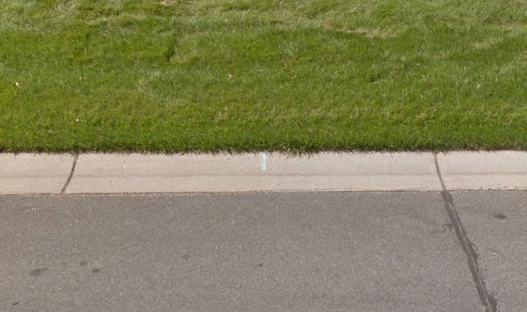

**1 ft**

**1 ft**

**3-5 ft**

**3-5 ft**

**Street and driveway parking during construction**

**Parking will be allowed on streets throughout construction between 7:00PM and 7:00AM.**

|  |  |
| --- | --- |
| **Construction operation** | **Where to park** |
| Concrete Removal and  Placement | * Park in your driveway if no curb is marked in front of your driveway or * If curb is marked in front of your driveway park on road where white paint is not present. * *If you require special accommodations, please contact the project hotline* |
| Pavement Removal and Grading/Paving Operations | * Park in your driveway. There may be short durations of 30-60 min when removals or paving occurring in front of your home causes temporary loss of access so plan accordingly. |

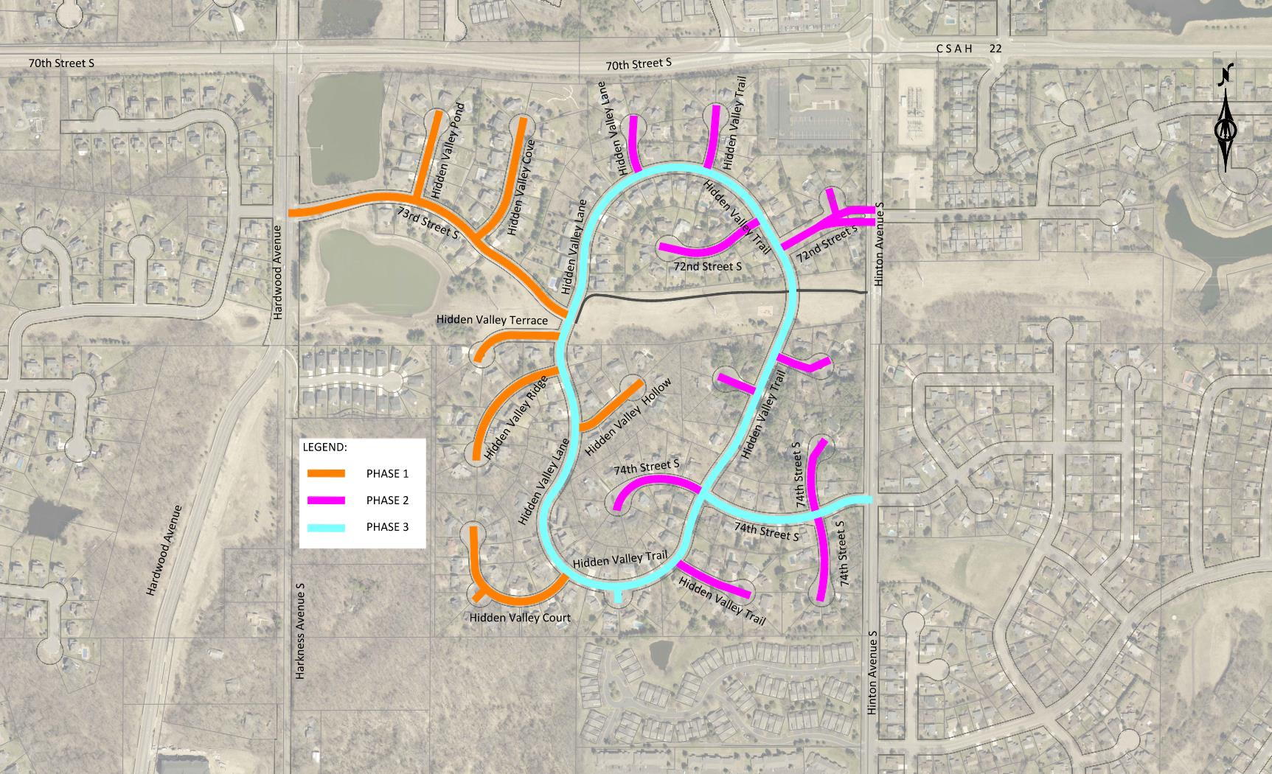

**Garbage and mail service**

Garbage service will remain the same with garbage pickup occurring on same day as it currently does throughout construction. Mail service will also remain the same unless otherwise notified in a separate notice.

**Stay Informed**

If you have any questions or concerns, please contact the project hotline or project email.

