July 25, 2019

Construction progressed this last week as the multi-use trail tunnel begins to take shape on the east side of highway 6. The contractor constructed and placed wooden concrete forms for the walls that sit on top of the footing that was poured over a week ago. Concrete will be poured into these forms by the very end of the week. Last week the contractor successfully relocated the Serpent Lake Sanitary Sewer District’s forcemain. After the forcemain was relocated out of the way it allowed for work to start on the tunnel itself. The trench was excavated and bedding placed for the precast concrete box sections. Ten of the nineteen box sections were installed this week with the use of a large crane. Each of these sections weigh roughly 32,000 pounds. The remaining sections will be installed by the middle of next week. Below are a few photos of the progress that has taken place onsite.

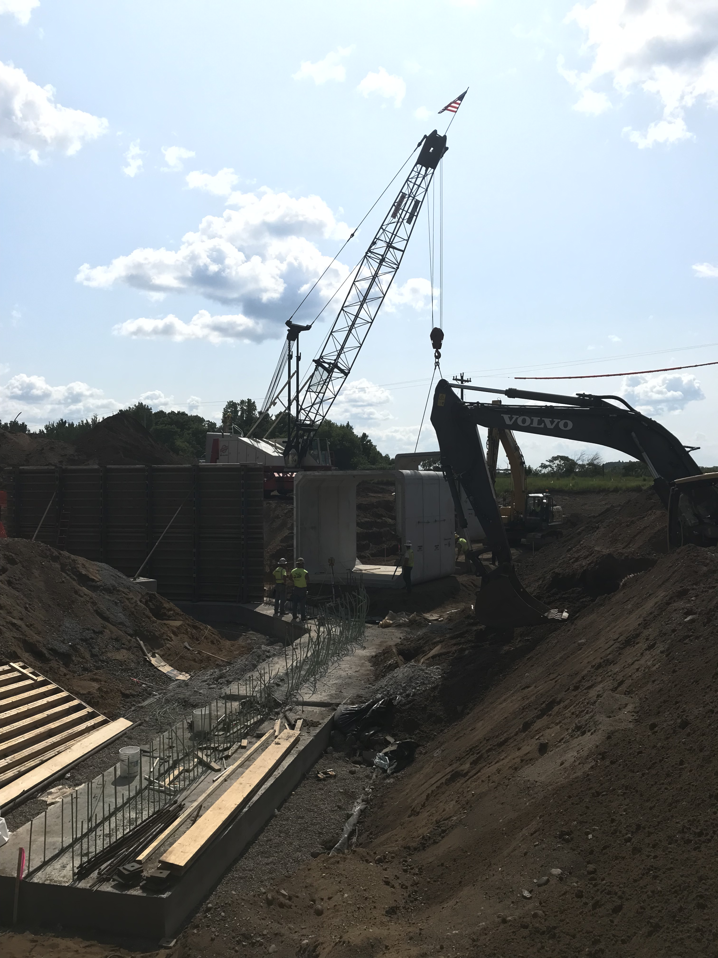
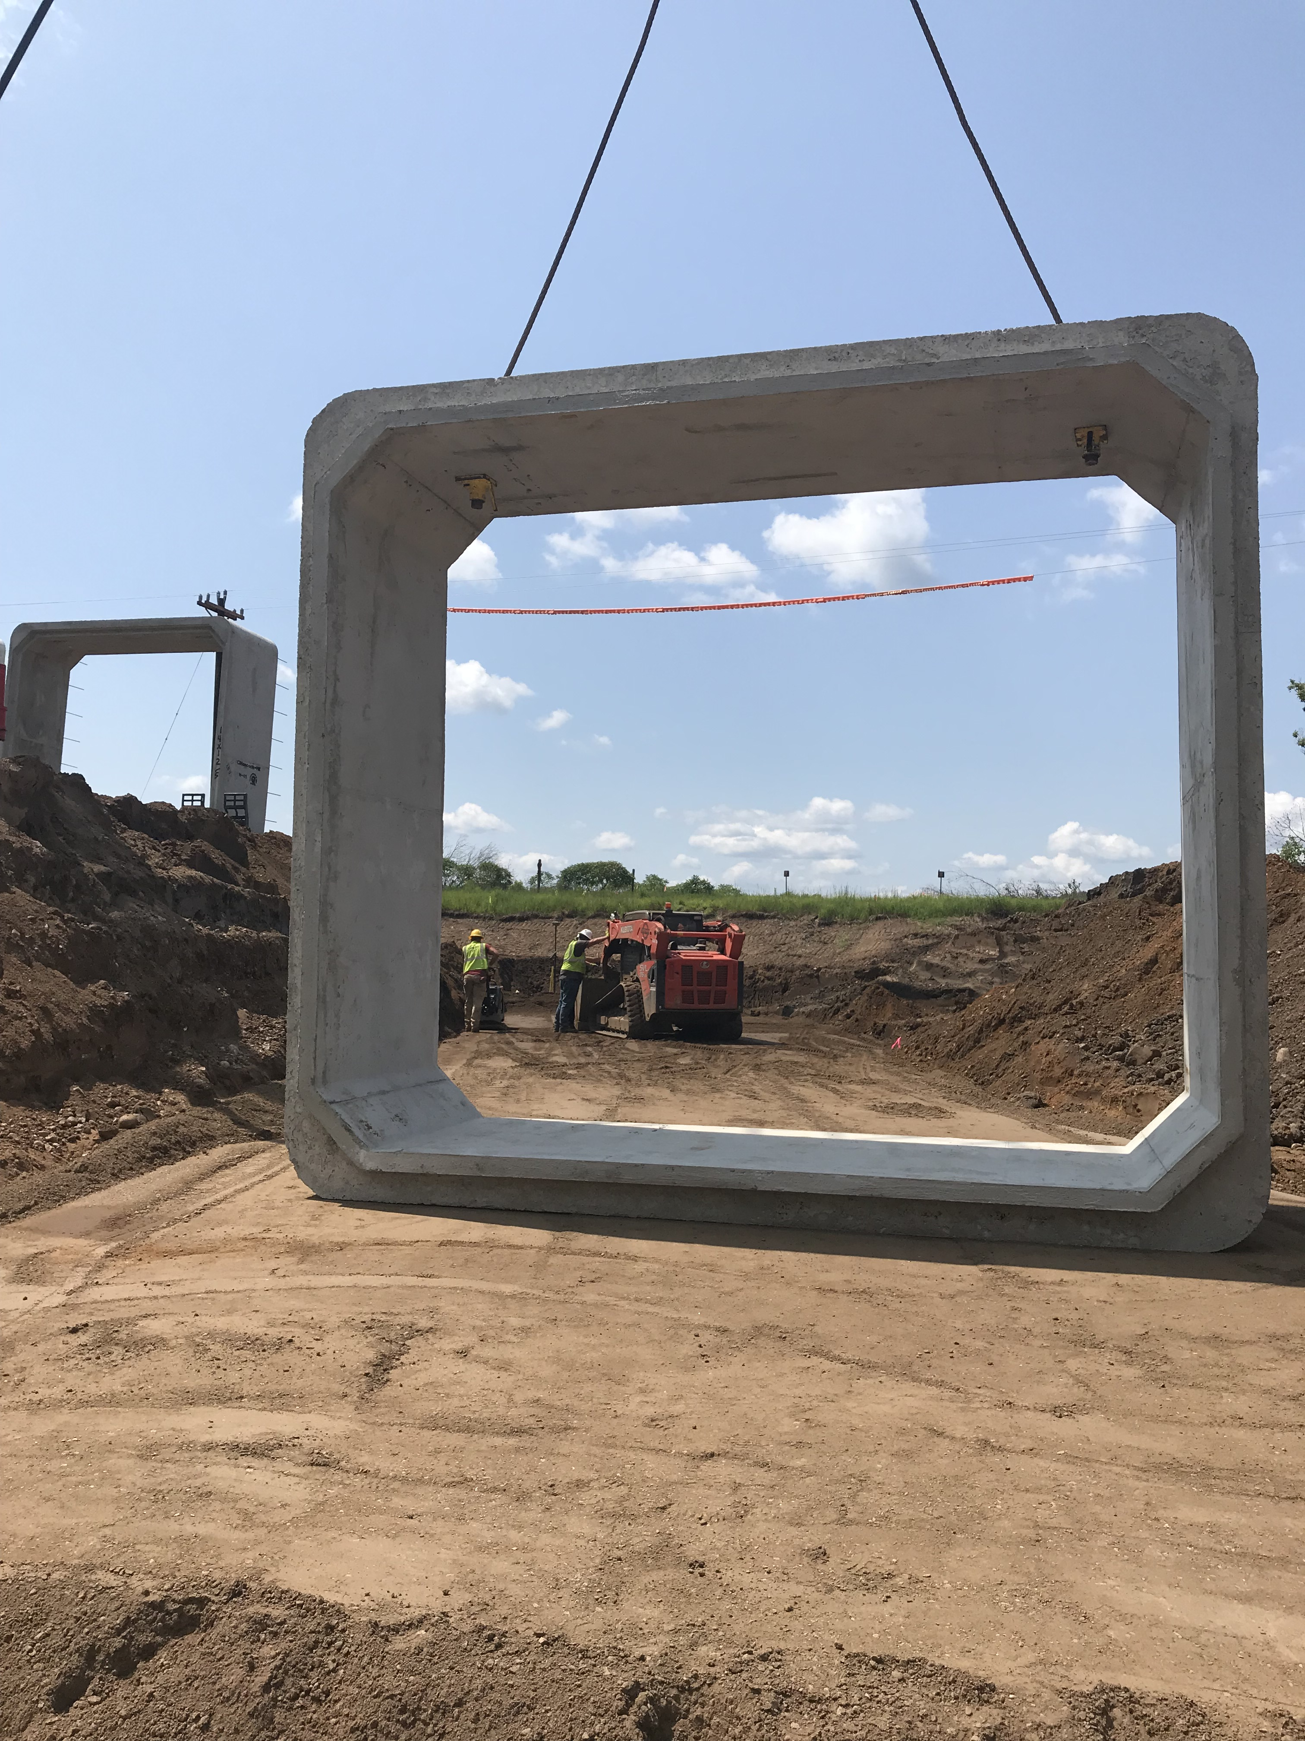

Pouring Concrete in the East Wing Wall Foundation

One of the Nineteen Concrete Box Sections that will Create the Tunnel
Setting the First Sections of the Tunnel

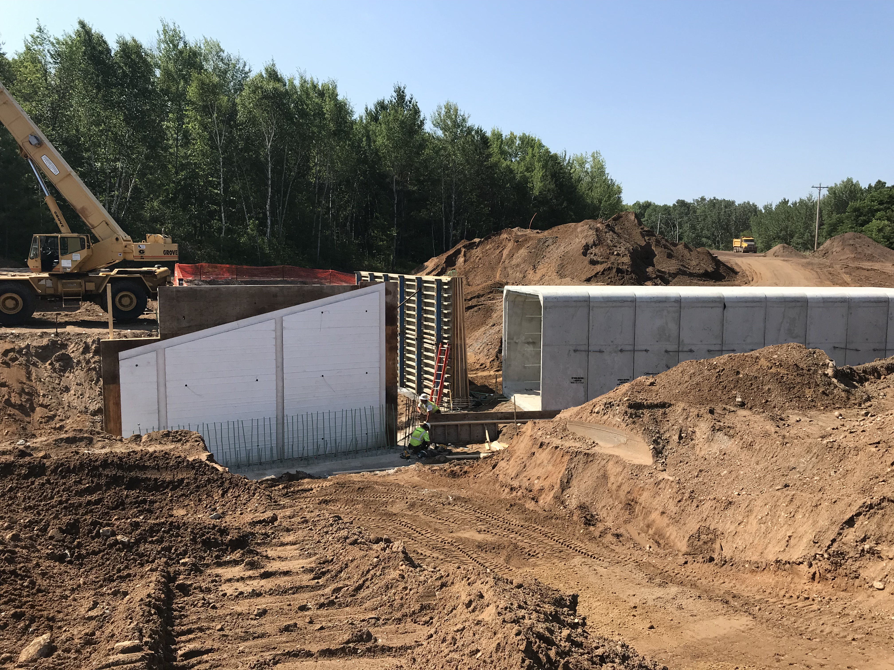

Preparing the Concrete Forms for the East Wing Walls

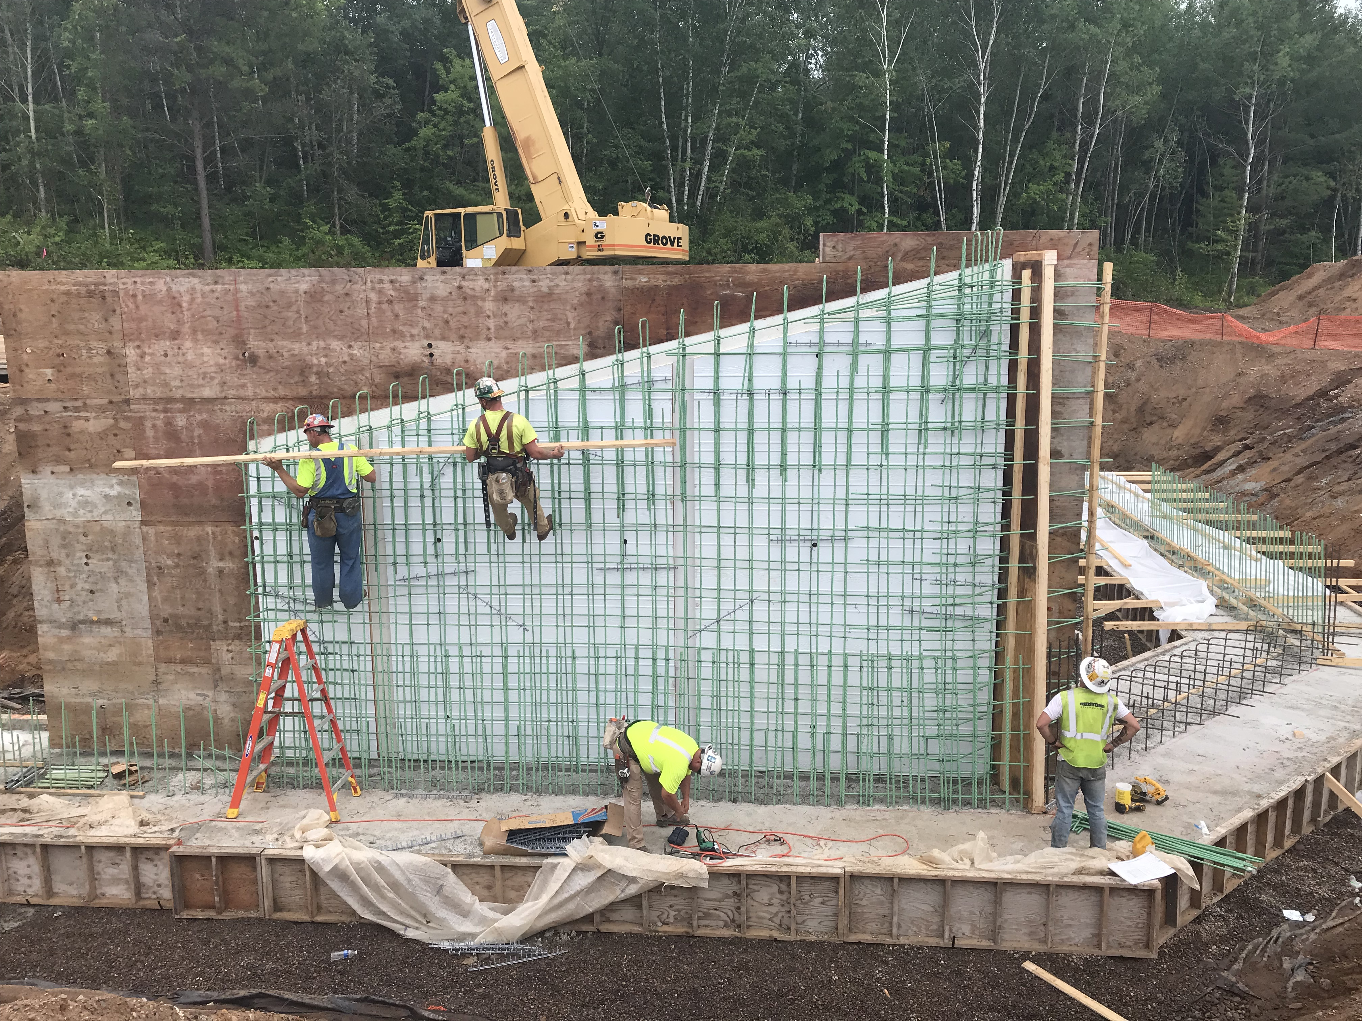
Steel Reinforcing Bars Being Tied into Place for the Wall

