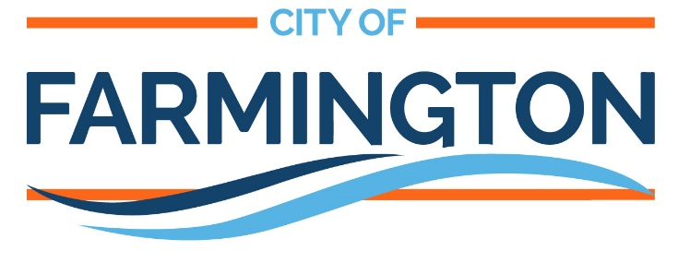

CONSTRUCTION NEWSLETTER

Contact
Safety
Project Schedule
Map & Phasing
Private Utilities
Access & Parking
Construction
Project Schedule

A phased construction schedule is proposed as shown in the map on the last page of this newsletter. The following is an overview of the earlier phases of the project schedule. For weekly construction updates please sign up for project updates on the project website.
Please contact Bob Flaws if you have an irrigation system or invisible dog fence in your front yard prior to the start of construction, if you have not already. This information will help minimize impacts to irrigation systems and dog fences during the construction process.

Early August
- Tree removals throughout project area
- Parking Lots construction will begin
- Erosion Control measures will be put in place
- Construction will begin with Stage 2 – (Division North of Spruce St)
  - Reclaiming and removals on Division Street
  - Watermain construction will begin
    - Short term water shutdowns, affected properties will be notified
  - Storm Sewer Construction will begin

Late August/ Ealy September
- Parking Lot construction will finish
- Stage 2 Utility construction will finish
TEMPORARY WATER SYSTEM
- Stage 2 Street Construction will begin
- Stage 3 Utility Construction will begin
Construction

Boulevard Tree Removals
Trees located within the public right-of-way are the responsibility of the City to maintain and clear when necessary. In early August, some boulevard trees will be removed by the City’s contractor. Property owners located adjacent to right-of-way with known or potential impacts to boulevard trees or private landscaping will be met with separately to discuss potential impacts to these items within the right-of-way (ROW). Proposed tree removals will be marked about a week prior to tree removals with a pink ribbon. It is the intent of the project’s design team and contractor to try to attempt to save all other, healthy trees in the neighborhood.
After tree removals, the street & utility reconstruction project will begin with removal of the existing pavement, which will be salvaged for reuse in building the new road. At about the same time, a temporary potable water distribution system will be established to serve each property during utility reconstruction on Farmington streets. The contractor will lay out temporary water pipes on the ground surface outside of the road, from which smaller temporary water service lines will be run to each house.

Please do not touch the temporary watermain including when mowing your lawn. Sewer service will remain unaffected during construction.

Once the temporary water system is tested and operational, the existing sanitary sewer main pipes, water main pipes, and storm sewer pipes will be removed and replaced in the roadway. Following installation of the mains, the contractor will remove and replace the sewer and water services to each property from the new main to the property line, which is typically located about 10-15 feet behind the curb. The existing sewer and water services between the property line and each house will not be replaced as part of the project, though they will be inspected at the property line. Utility construction typically lasts about 4 to 5 weeks after the pavement is removed.
Street reconstruction will follow utility work and begin by excavating and removing all material within the upper two feet of the existing roadbed to make space for the new sand/gravel base and surface pavement. The old pavement material, now ground up into gravel for reuse, will be brought back and placed in the street as the new (recycled) roadbed. This process will be followed with installation of new curb and gutter, concrete driveway aprons, and asphalt pavement. Two layers of asphalt will be installed in separate processes. Street reconstruction typically lasts about 4 weeks following utility construction.
Boulevard restoration, including installation of organically-rich topsoil, sod, and new trees will occur following the first layer of street paving. The final layer of pavement will be installed in the spring of 2023 to allow for any settlements to occur after 1 freeze/thaw cycle.
The construction process results in a great product at its completion, but can test one’s patience along its course. While the negatives of construction are in many ways unavoidable, the City aims to reduce the burden through working with the City’s contractor to minimize disruption, routine mailings and other communication, and on-site assistance for residents.
Water & Sewer Replacement
Property Line to Home
REPORTING OUTAGES
Temp Water – Rudy Miller, BCM (507) 456-2207
Gas – Call 911 / Minnesota Energy 1-800-889-4970
Electric – Xcel Energy – 1-800-895-1999
Telephone – Frontier – 1-800-921-8101
Cable TV – Charter Spectrum – 1-833-780-1880

When the street and utilities are under construction, the contractor will need all of the space in the street possible. Therefore parking will not be allowed on the project area streets during the working hours. Access to driveways will be provided as much as possible. Temporary access restrictions should be anticipated during the workday. The project team understands the need for access to each property, therefore the streets will be temporarily restored at the end of each workday and access to private driveways will generally be available each night.
Access, Parking, & Communication
During street & utility reconstruction, access conditions are usually most challenging after rainfall. Heavy traffic over muddy streets makes conditions worse. Residents will be encouraged to drive on paved roadways whenever that alternative exists.
Typical working hours for the project will be 7 a.m. to 7 p.m., Monday through Friday, and 8 a.m. to 6 p.m. on Saturdays if necessary. No work is allowed on Sundays or holidays.
Finally, to combat the challenges of construction, the City has developed a multi-faceted approach to communication. In general, newsletters will be provided on a monthly basis, project website updates will be completed weekly, and property notices will be delivered to front doors as often as daily. Once construction begins, residents can contact Bob Flaws who is the on-site contact there to represent the City and its residents through the construction process.
Water and sewer service lines are privately owned by the properties they serve. Throughout the project area, to prevent future costly repairs by homeowners the City will be replacing each property’s water and sanitary sewer service pipes from the main (in the street) to the property line (about 10’-15’ behind the curb). At this connection point, the existing sewer and water service pipes will remain. These existing lines will be inspected at the property line prior to reconnection.
On past City of Farmington projects, some property owners have viewed the street and utility project as an opportunity to replace water and sewer service lines in full, all the way to the home, even when not required by environmental or health codes. While the City does not participate in such work, it is willing to coordinate with contractors to make this process as seamless as possible and provide contacts for plumbing contractors who have done this work:
Safety
Krueger Excavating | 952-447-8335
Sauber Plumbing & Heating | 651-463-7434
Ouverson Sewer & Water** | 612-751-6888
Highview Plumbing** | 952-933-8600
**Also provide trenchless replacement
Residents interested in undertaking additional private plumbing work on their own can contact these companies directly. Please note, residents do not need to use these contractors to do this work nor is this intended as a list of recommended plumbers. This list is provided for convenience and at the request of property owners.
Garbage & Recycling
Garbage and recycling service will continue on a normal schedule throughout the project. Residents should bring garbage & recycling bins to the end of their driveway at the usual times. If the garbage or recycling truck cannot reach your driveway because of construction activity, the Contractor will bring your bins to the garbage or recycling truck and return the empty bins to your driveway.
Mailboxes
The existing mailboxes in the project area will be removed. Your mail will be delivered to a group of mailboxes at a location selected by the postmaster for the duration of the project. You will be notified of your new mail delivery location and a date the change will take affect once the new location has been determined. Please retrieve your mail from the group of mailboxes located at a specific area for your project.
Your existing mailbox will be placed on your property for the duration of the project. At the end of the project, the contractor will remove the temporary group of mailboxes and reinstall your existing mailbox at a location on your property determined by the postmaster. If you wish to have a new mailbox installed, provide the contractor with the new box and post at that time. You will be notified in advance of mailbox installation.

The contractor will do everything they can to make the project area safe for residents. However, residents should be aware of their surroundings when walking or driving near construction equipment. The City asks that residents keep their distance from construction equipment in use and utility trenches. There are also materials that can cause harm if caution is not used such as hot asphalt pavement immediately after being placed. Please keep children and pets away from construction activity and open trenches as they might not be aware of the dangers. If you see anything that you feel is unsafe, please do not hesitate to call Bob Flaws.
Contact and Website Info
Bob Flaws, of Bolton & Menk, will be on the project site representing the City and its residents. If you have any questions regarding this newsletter, the project, or anything in general, you may approach him on site or call his cell phone at (612) 328-0742. He can also be reached via email at robert.flaws@bolton-menk.com
Matt Blazer, of Bolton & Menk, Inc., is the Project Manager overseeing the construction process and will serve as a secondary point of contact. He can be reached at (612) 756-4823 or matt.blazer@bolton-menk.com
Matt Decur is the Assistant City Engineer for the City of Farmington. He can be reached at (651) 280-6846 or mdecur@farmingtonmn.gov
Website: The website will be updated approximately weekly with the latest project info throughout construction, and residents can sign-up for weekly email updates through the website. The site URL is:
www.farmingtonmn.gov/2022SUP
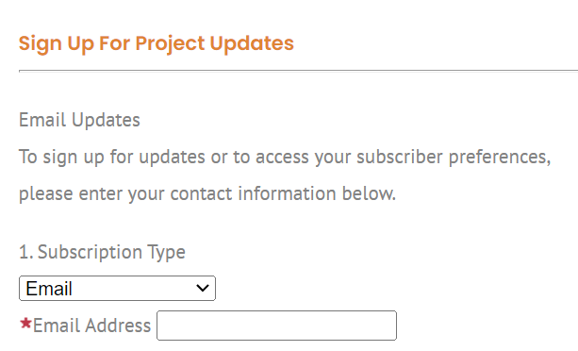

Project Location Map
2022 SPRUCE STREET & UTILITY IMPROVEMENTS
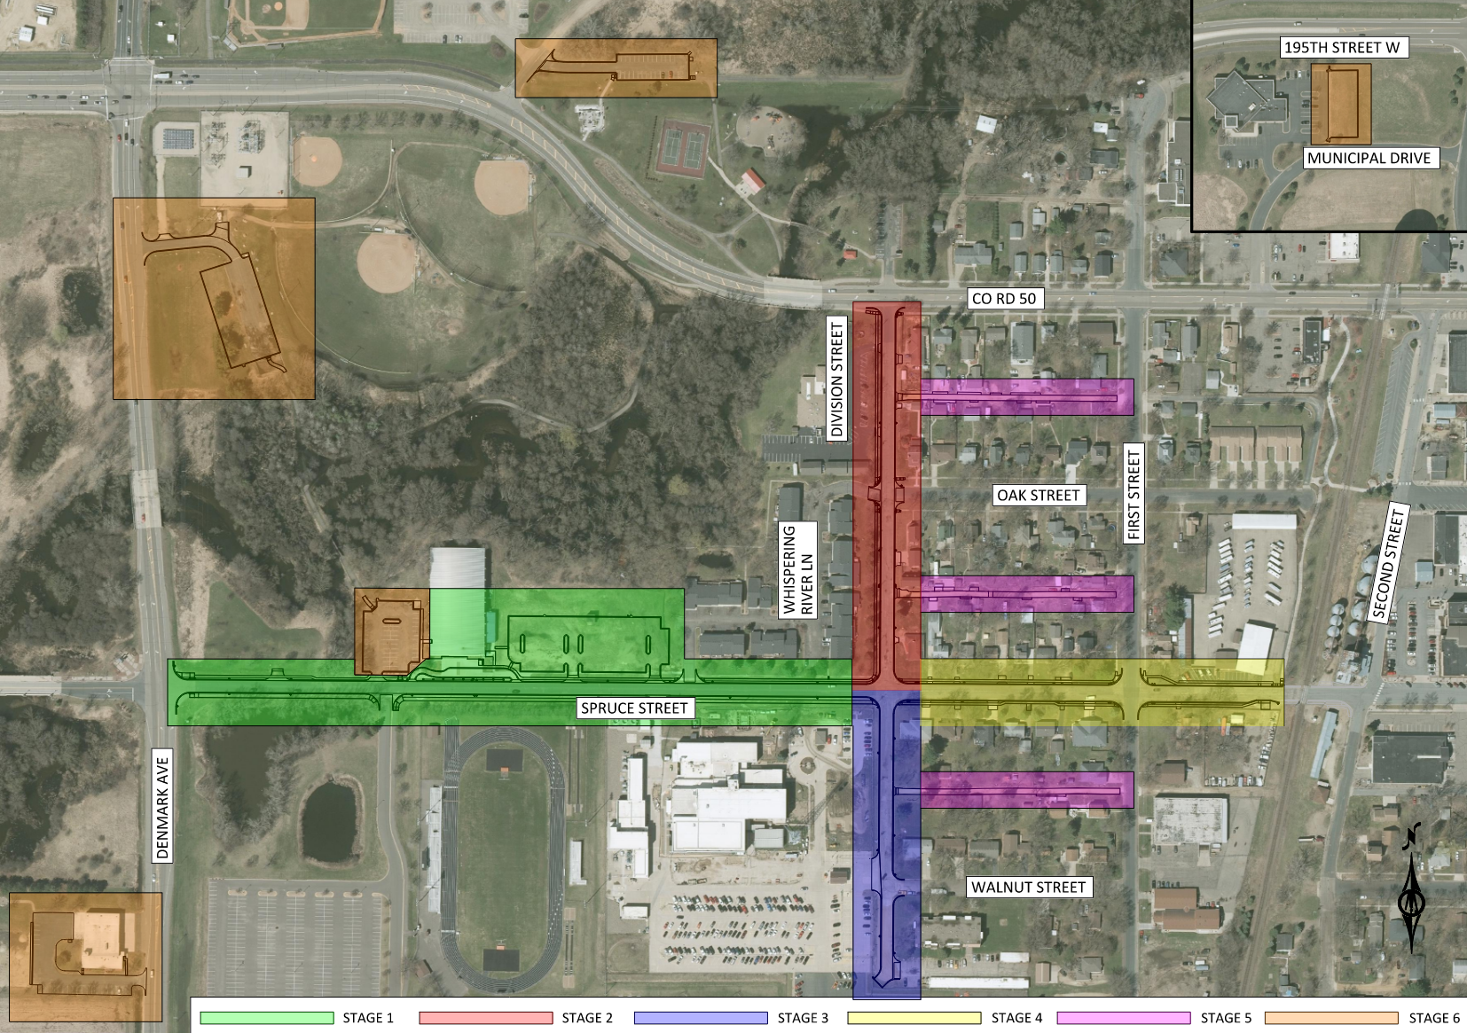
MID SEPTEMBER – MID OCTOBER
MID SEPTEMBER – MID OCTOBER
MID AUGUST – MID SEPTEMBER
SEPTEMBER - OCTOBER
MID AUGUST – MID SEPTEMBER
EARLY OCTOBER – LATE OCTOBER

