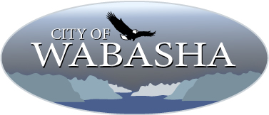

2023 Street & Utility Improvement Project

Business Questionnaire
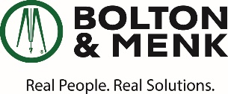
The following information will help the design team understand your business needs during construction and inform the phasing and staging plans.
Property Address:______________________________________________________________
Business Name: _______________________________________________________________
Primary Contact Name: _________________________________________________________
Business Address (if different than property address):_________________________________
___________________________________
Phone Number: _____________________
Contact Email(s): __________________________
__________________________
Business Hours:
Monday
Tuesday
Wednesday
Thursday
Friday
Saturday
Sunday
Deliveries: Please tell us about the deliveries you receive at your business including frequency, regular or irregular schedule, size of delivery truck, delivery location and any other pertinent information you think the city should know: ________________________________________
________________________ ____________________________
Access Needs: Please tell us about the access needs for your property including regular and alternate customer entrances, access points for employees and deliveries, peak times for access, other access needs (second story apartments):
________________________ ____________________________
Other information you would like the city know:
________________________ ____________________________
If you prefer to fill out this form, please email a copy of completed form to Katy Gehler (Bolton & Menk, Inc) at Katy.Gehler@bolton-menk.com

